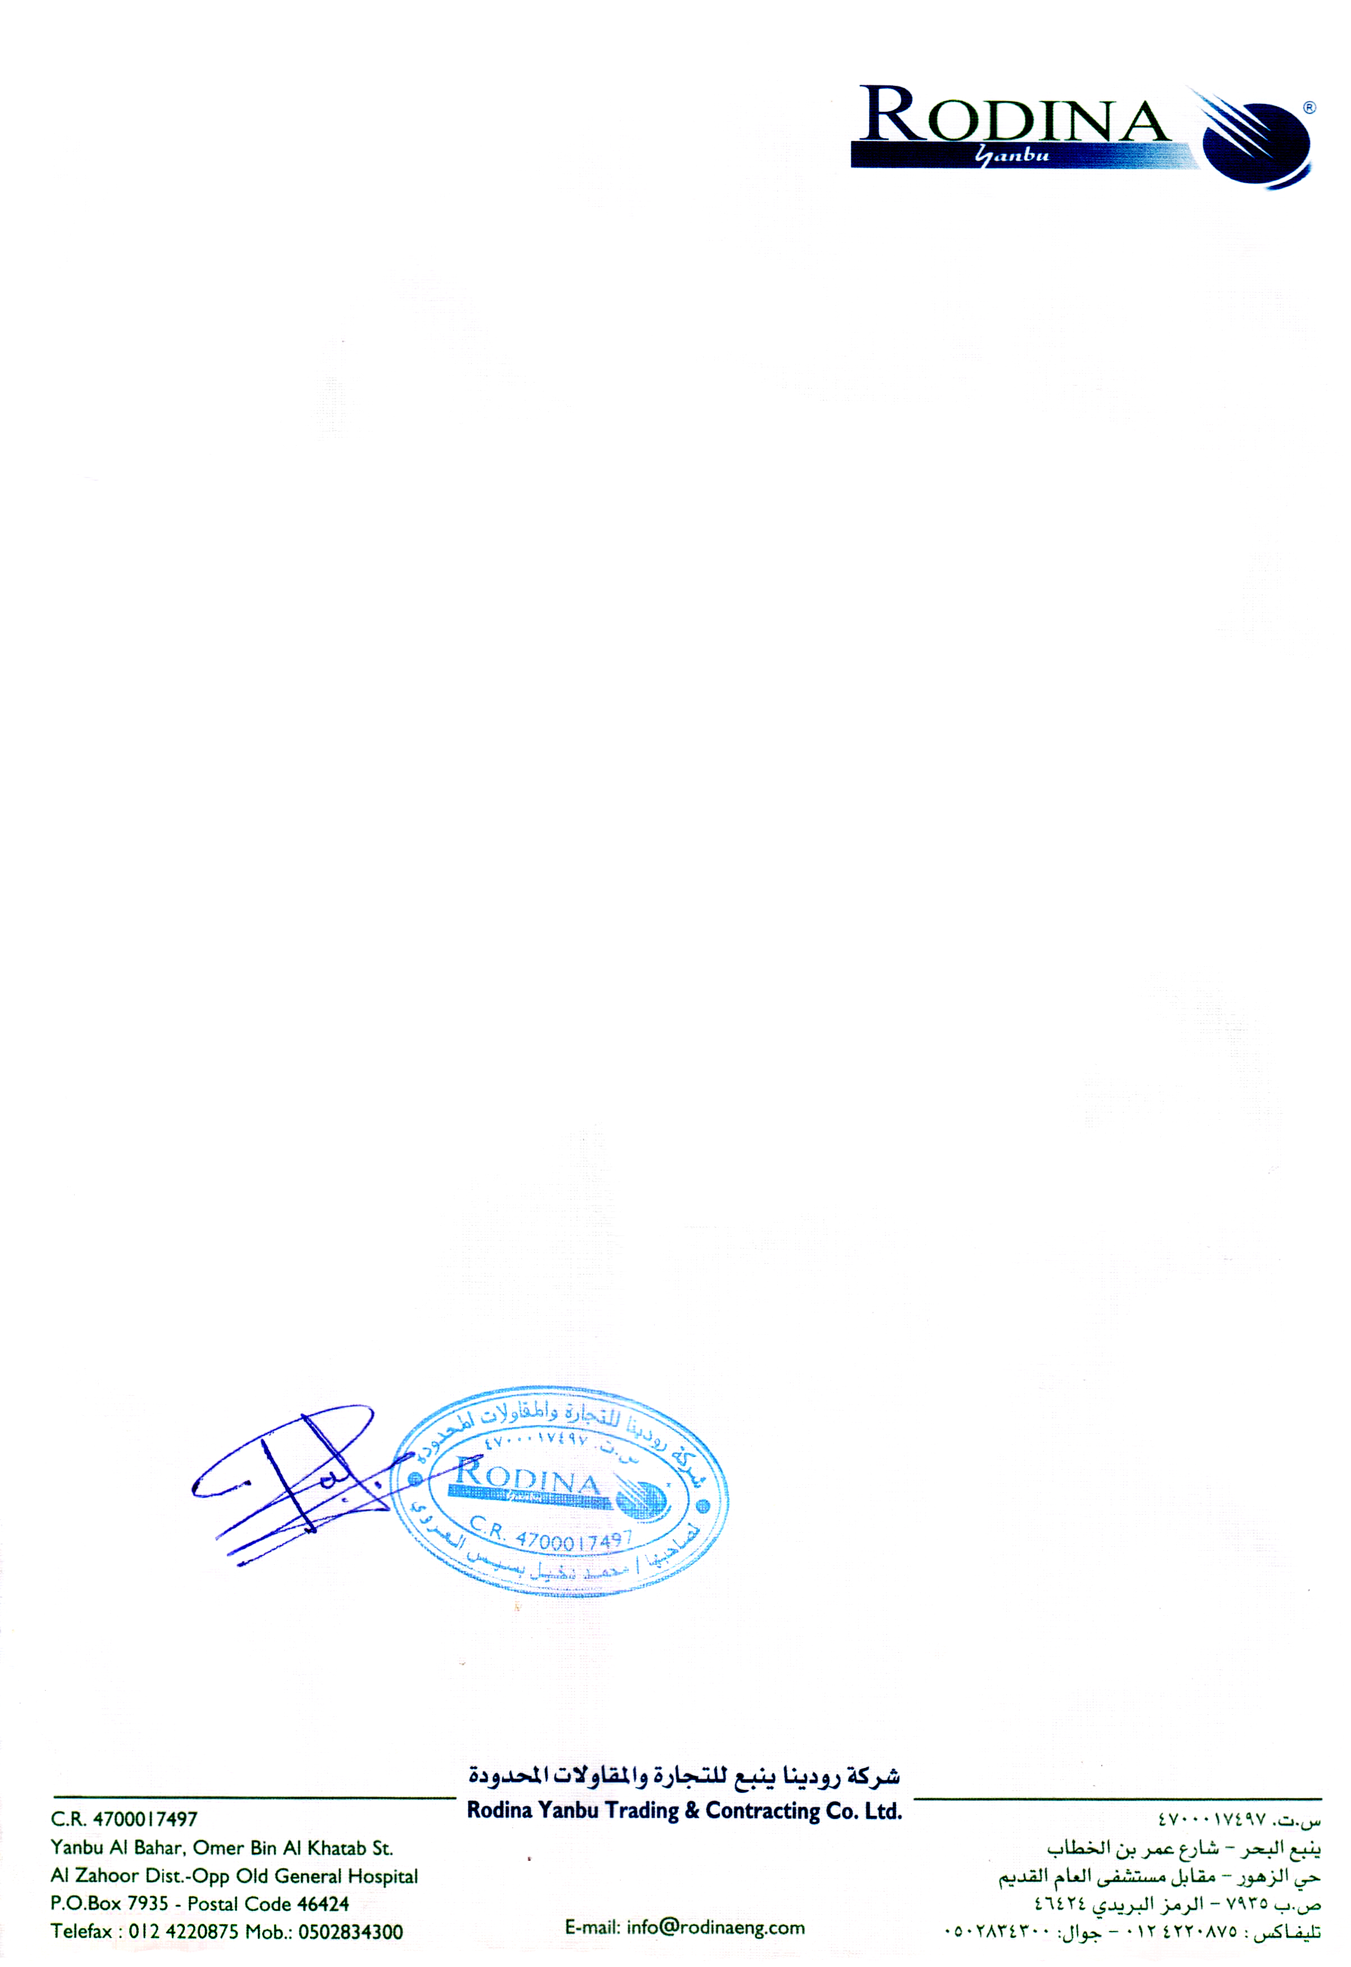

TO WHOM IT MAY CONCERN

This is to certify that Mr. <Name> S/o <fname> holding Pakistani Passport No. <Passport> was in the employment of our company at Tecnicas Reunidas Co. Jazan Project from <From> to <To>.

Mr. <Name> was serving the company in the capacity of <Designation>.

This certificate is given to him upon his request without any obligation towards the company.

For ROBDINA YANBU TRADING & CONTRACTING CO. LTD.

YANBU, KSA

Abdul Majeed Ellathody

HR Manager